**Gaussian Process Regression**

**Documentation**

<https://scikit-learn.org/stable/modules/gaussian_process.html>

**Indicator**

**LuxAlgo GPR Indicator**

Working model ( red line indicates the direction of the movement of price)

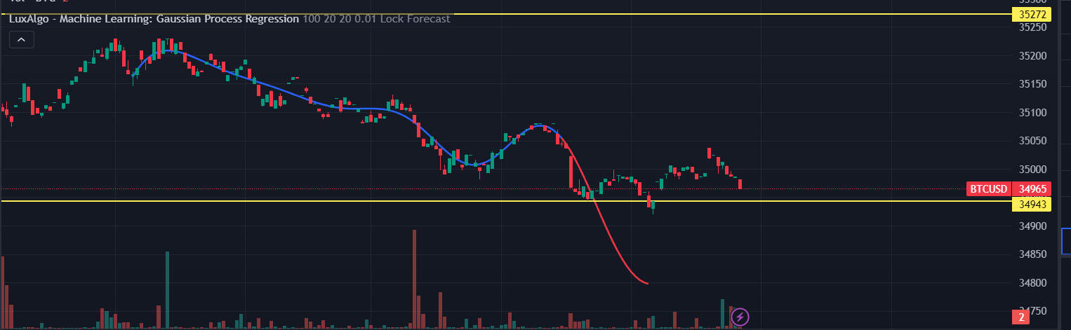

Factors to consider :

* Performance in sideways market and its identification
* Reversals
* Breakouts

**BASIC INDICATORS:**

1. **The relative strength index (RSI):**

The relative strength index (RSI) refers to a momentum indicator that analyses the pace and variation of price movements. The value of RSI ranges from 0 to 100. Its purpose is to track price momentum changes. When the RSI of a security is above 70, it is considered overbought; it is deemed over sold when it is less than 30.

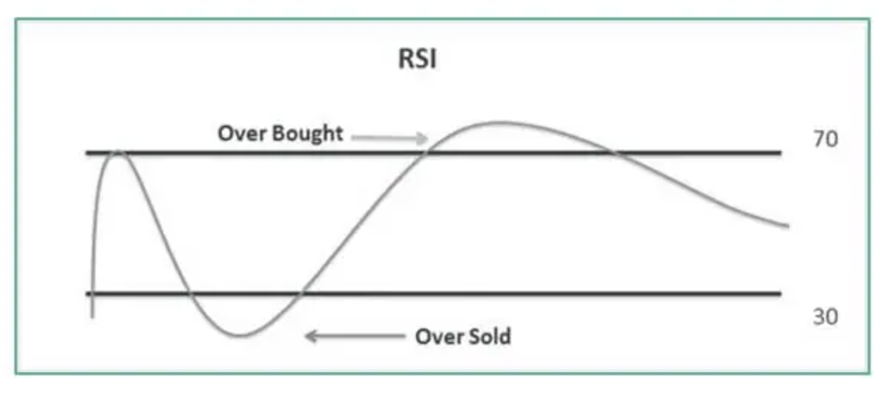

RSI Formula:

The RSI formula can be calculated using the mean changes in closing prices for a certain period.

relative strength (RS) = Umean / Dmean

Umean = mean of all the upward movement of prices of the last N bars (N = duration of RSI)

Dmean = mean of all the downward movement of prices of the last N bars (N = duration of RSI)

After that, RSI is calculated using the following formula:

RSI = 100 – (100/[1 + {14-Day Average Gain/14-Day Average Loss}])

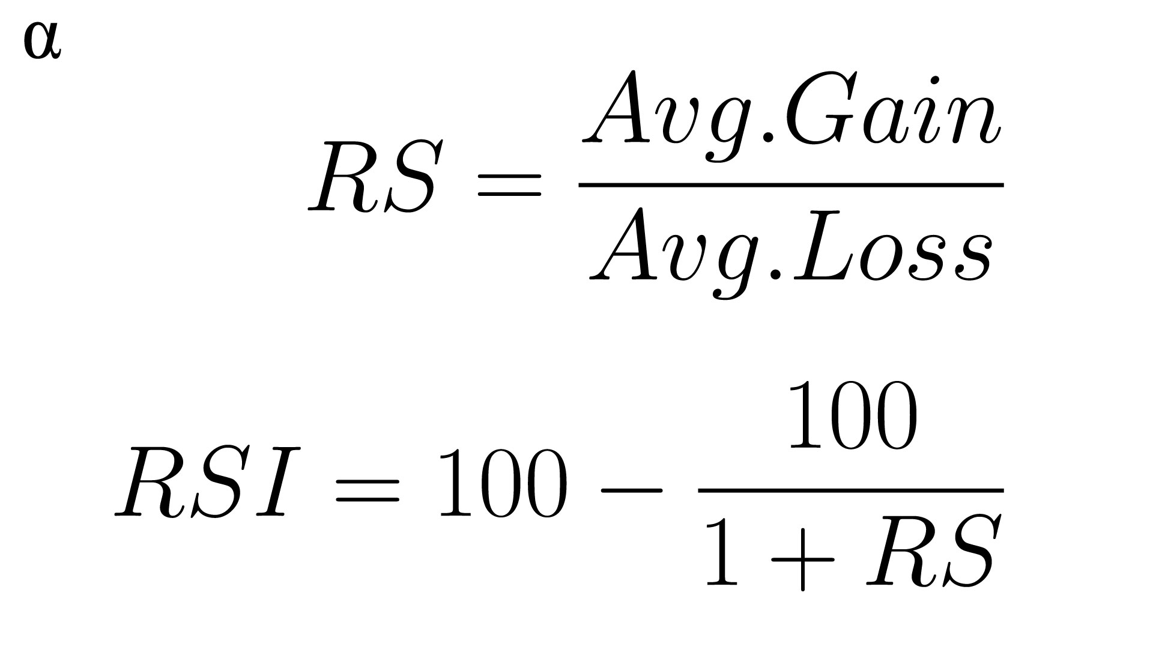

Python Code:

def calculate_rsi(data, period=14):

delta = data['Close'].diff(1)

gain = delta.where(delta > 0, 0)

loss = -delta.where(delta < 0, 0)

avg_gain = gain.rolling(window=period, min_periods=1).mean()

avg_loss = loss.rolling(window=period, min_periods=1).mean()

rs = avg_gain / avg_loss

rsi = 100 - (100 / (1 + rs))

return rsi

1. **Bollinger Band:**

The Bollinger Band is composed of three lines: a simple moving average (SMA), or the middle band, and an upper and lower band. The upper and lower bands are typically 2 standard deviations +/- from a 20-day simple moving average and can be modified. When the price continually touches the upper Bollinger Band, it can indicate an overbought signal. If the price continually touches the lower band, it can indicate an oversold signal.

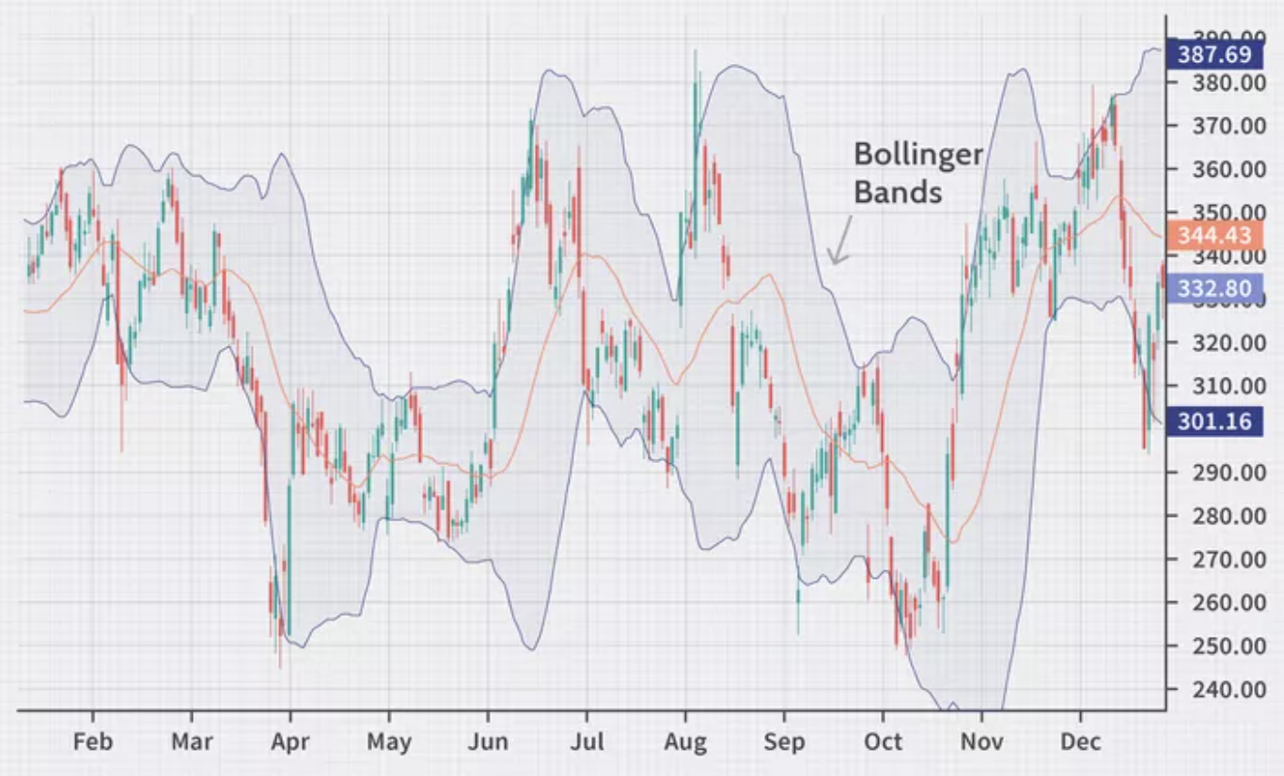

**Formula:**

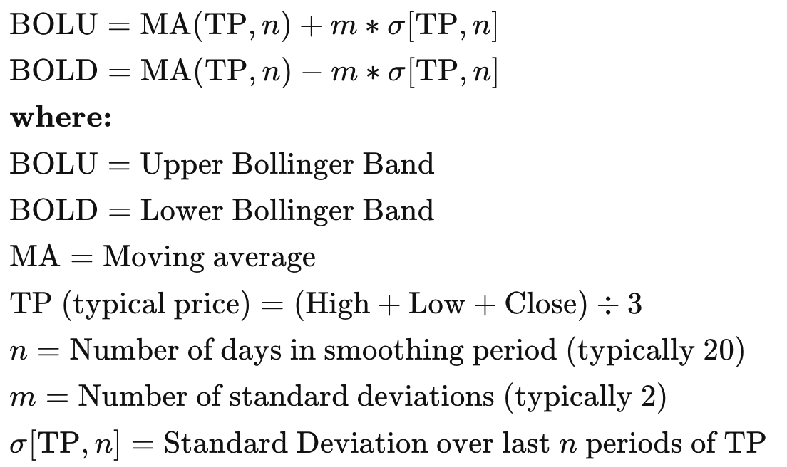

**Python code:**def calculate_bollinger_bands(data, window=20, num_std=2):

# Calculate the rolling mean and standard deviation

rolling_mean = data['Close'].rolling(window=window).mean()

rolling_std = data['Close'].rolling(window=window).std()

# Calculate Bollinger Bands

upper_band = rolling_mean + (rolling_std * num_std)

lower_band = rolling_mean - (rolling_std * num_std)

return upper_band, lower_band

1. **Moving Average Convergence Divergence (MACD):**

It is a trend-following momentum indicator that shows the relationship between two moving averages of an asset's price. It is calculated by subtracting the 26-period Exponential Moving Average (EMA) from the 12-period EMA.

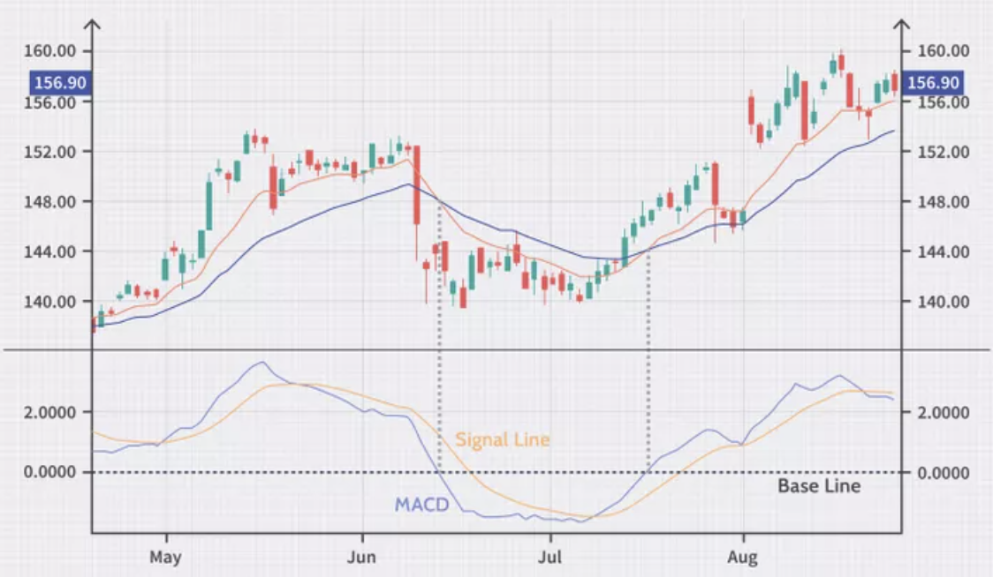

**Formula**:

MACD = 12-Period EMA − 26-Period EMA

MACD=12-Period EMA − 26-Period EMA

**Python code:**

def calculate_macd(data, short_window=12, long_window=26, signal_window=9):

# Calculate short-term (fast) EMA

short_ema = data['Close'].ewm(span=short_window, adjust=False).mean()

# Calculate long-term (slow) EMA

long_ema = data['Close'].ewm(span=long_window, adjust=False).mean()

# Calculate MACD line

macd_line = short_ema - long_ema

# Calculate signal line

signal_line = macd_line.ewm(span=signal_window, adjust=False).mean()

# Calculate MACD histogram

macd_histogram = macd_line - signal_line

return macd_line, signal_line, macd_histogram

1. **Fibonacci Retracement:**

Fibonacci Retracement is a technical analysis tool that uses horizontal lines to indicate areas of support or resistance at the key Fibonacci levels before the price continues in the original direction. These levels are based on the Fibonacci sequence and are often used by traders to identify potential reversal points in the price movement of an asset.

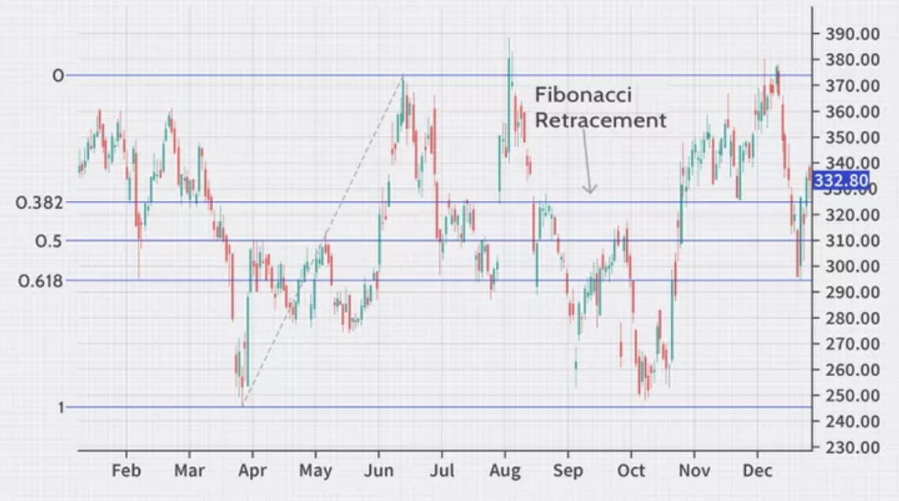

**Formula:**Fibonacci retracement levels do not have formulas. When these indicators are applied to a chart, the user chooses two points. Once those two points are chosen, the lines are drawn at percentages of that move.

Suppose the price rises from $10 to $15, and these two price levels are the points used to draw the retracement indicator. Then, the 23.6% level will be at $13.82 ($15 - ($5 × 0.236) = $13.82). The 50% level will be at $12.50 ($15 - ($5 × 0.5) = $12.50).

**Python code:**

def plot_fibonacci_retracement(data, start_index, end_index, levels=(0.236, 0.382, 0.618, 1.0)):

price_data = data['Close'][start_index:end_index]

highest_point = max(price_data)

lowest_point = min(price_data)

price_range = highest_point - lowest_point

fib_levels = [lowest_point + level * price_range for level in levels]

plt.figure(figsize=(10, 5))

plt.plot(price_data, label='Price')

for level in fib_levels:

plt.axhline(level, color='red', linestyle='--', alpha=0.7)

def plot_fibonacci_retracement(data, start_time, end_time):

if isinstance(start_time, str):

start_time = pd.to_datetime(start_time)

if isinstance(end_time, str):

end_time = pd.to_datetime(end_time)

if start_time >= end_time:

raise ValueError("End time must be after start time.")

if start_time not in data.index or end_time not in data.index:

raise ValueError("Start and end times must be within the DataFrame's index range.")

price_data = data['close'].loc[start_time:end_time]

highest_point = price_data.max()

lowest_point = price_data.min()

price_range = highest_point - lowest_point

fib_levels = {

'23.6%': highest_point - price_range * 0.236,

'38.2%': highest_point - price_range * 0.382,

'50.0%': highest_point - price_range * 0.5,

'61.8%': highest_point - price_range * 0.618,

'100.0%': lowest_point

}

plt.figure(figsize=(14, 7))

plt.plot(price_data.index, price_data, label='Price')

for key, level in fib_levels.items():

plt.axhline(level, color='red', linestyle='--', alpha=0.7, label=f'Fib Level {key} at {level:.2f}')

plt.title(f'Fibonacci Retracement Levels from {start_time} to {end_time}')

plt.xlabel('Date')

plt.ylabel('Price')

plt.legend()

plt.show()

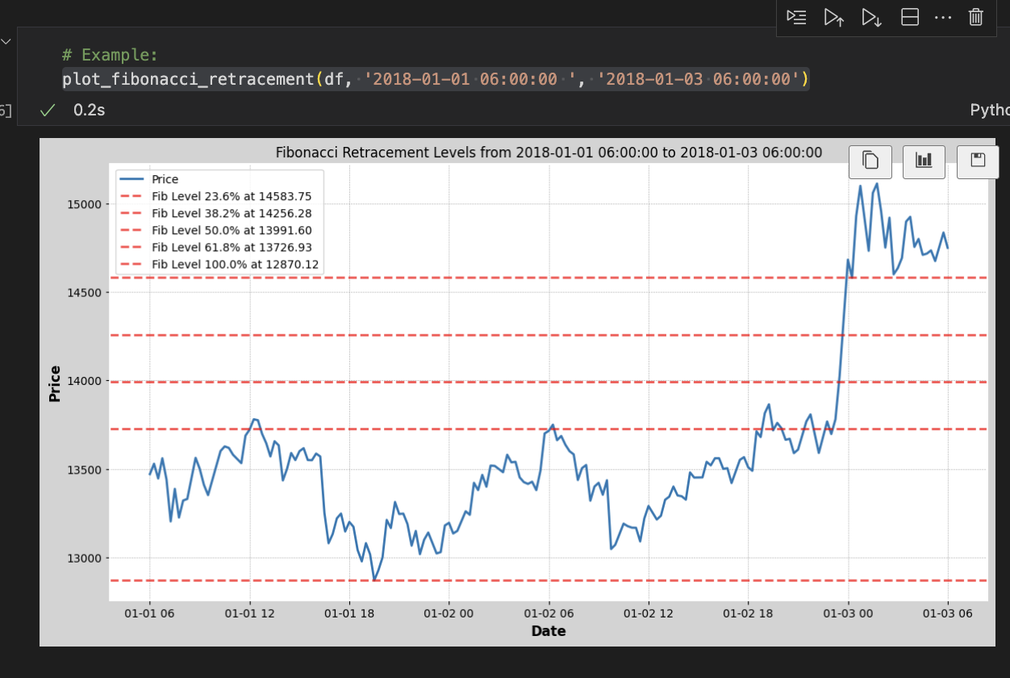

1. **Stochastic Oscillator:**

The Stochastic Oscillator is a momentum indicator that compares a particular closing price of an asset to its price range over a certain period. It consists of two lines: %K, which is the main line, and %D, which is a moving average of %K. The Stochastic Oscillator is often used to identify overbought or oversold conditions in a market, indicating potential reversal points.

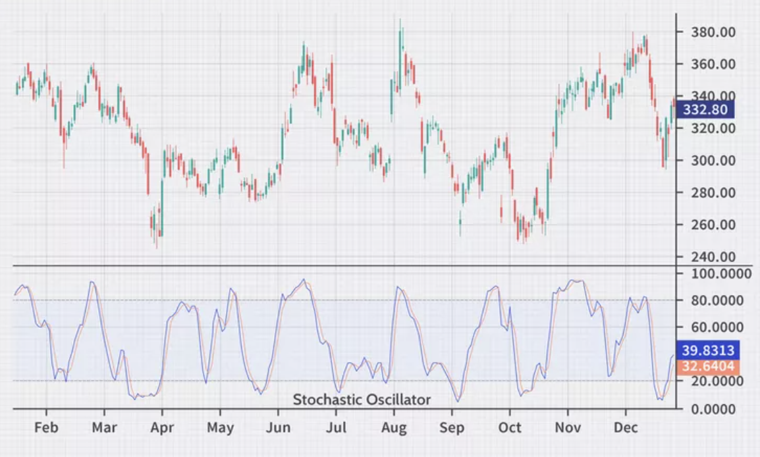

**Formula:**

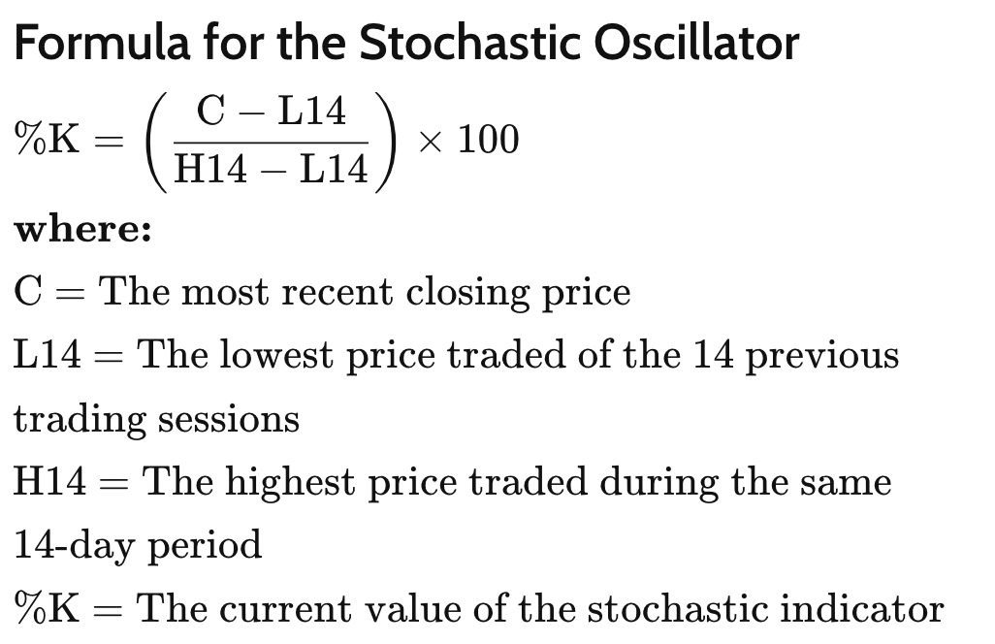

**Python code:**

def calculate_stochastic_oscillator(data, k_period=14, d_period=3):

# Calculate %K

data['Lowest_Low'] = data['Low'].rolling(window=k_period).min()

data['Highest_High'] = data['High'].rolling(window=k_period).max()

data['%K'] = ((data['Close'] - data['Lowest_Low']) / (data['Highest_High'] - data['Lowest_Low'])) * 100

# Calculate %D (3-day simple moving average of %K)

data['%D'] = data['%K'].rolling(window=d_period).mean()

return data['%K'], data['%D']

1. **Ichimoku Cloud:**

It is a versatile indicator in technical analysis that provides information about support and resistance levels, trend direction, and momentum. It consists of several components, including the Kijun-sen, Tenkan-sen, Senkou Span A, Senkou Span B, and the Kumo (cloud). Traders use the Ichimoku Cloud to identify potential trend reversals, trend strength, and possible entry or exit points.

The Ichimoku Cloud is composed of five lines or calculations, two of which comprise a cloud where the difference between the two lines is shaded in.

The lines include a 9-period average, a 26-period average, an average of those two averages, a 52-period average, and a lagging closing price line.

The cloud is a key part of the indicator. When the price is below the cloud, the trend is down. When the price is above the cloud, the trend is up.

The above trend signals are strengthened if the cloud is moving in the same direction as the price. For example, during an uptrend, the top of the cloud is moving up, or during a downtrend, the bottom of the cloud is moving down.

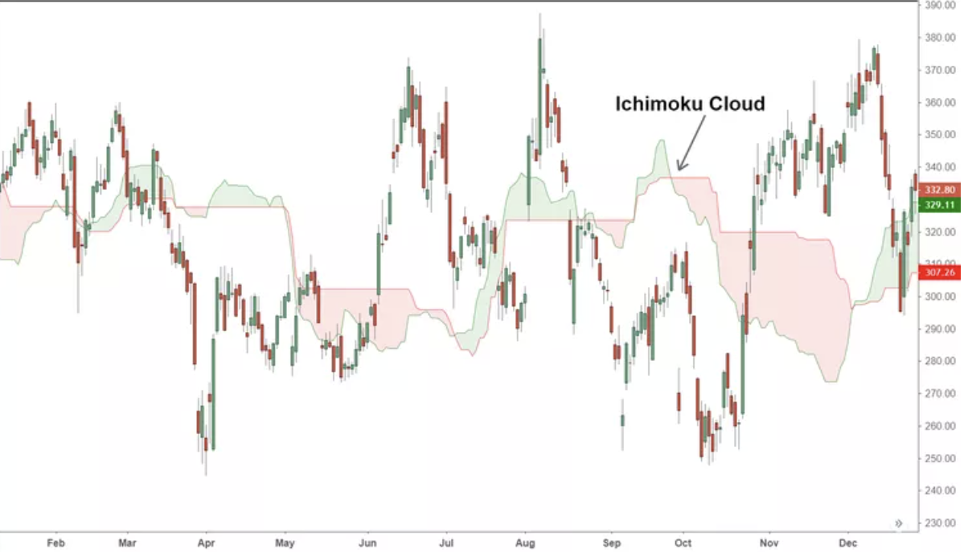

**Formula:**

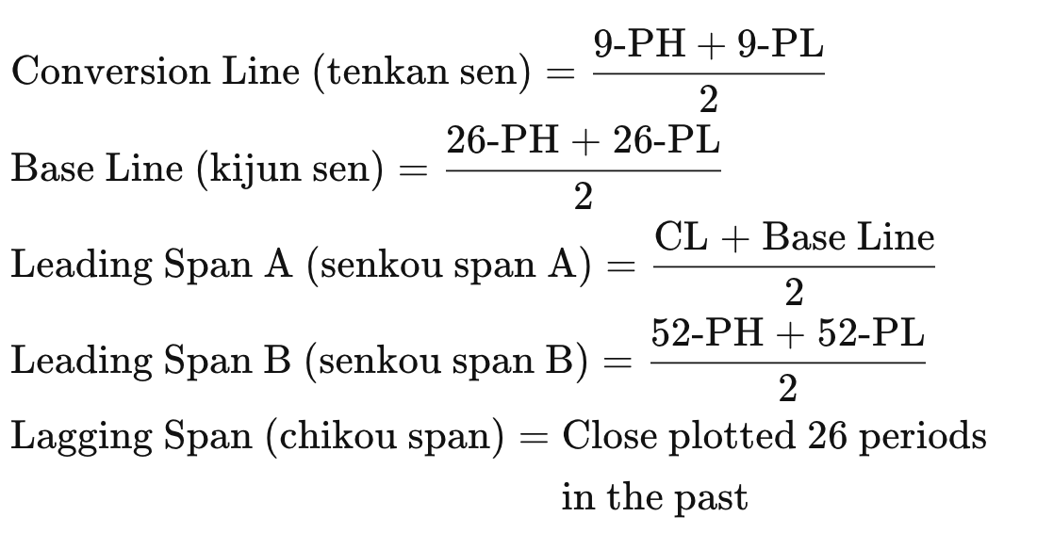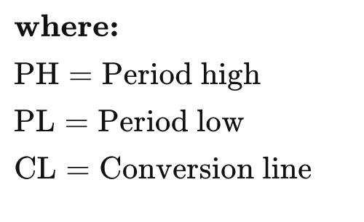

**Python code:**

df = pd.read_csv('btcusdt_15m.csv')

df.rename(columns={'datetime': 'Date'}, inplace=True)

df['Date'] = pd.to_datetime(df['Date'])

df.set_index('Date', inplace=True)

def plot_ichimoku(df, start_date=None, end_date=None):

if not isinstance(df.index, pd.DatetimeIndex):

raise ValueError("DataFrame index must be a DateTimeIndex")

if start_date:

start_datetime = pd.to_datetime(start_date)

df = df[df.index >= start_datetime]

if end_date:

end_datetime = pd.to_datetime(end_date) + pd.Timedelta(days=1) - pd.Timedelta(minutes=15)

df = df[df.index <= end_datetime]

if df.empty:

raise ValueError("No data available for the specified date range")

# Calculating Ichimoku components

df['tenkan_sen'] = (df['high'].rolling(window=9).max() + df['low'].rolling(window=9).min()) / 2

df['kijun_sen'] = (df['high'].rolling(window=26).max() + df['low'].rolling(window=26).min()) / 2

df['senkou_span_a'] = ((df['tenkan_sen'] + df['kijun_sen']) / 2).shift(26)

df['senkou_span_b'] = ((df['high'].rolling(window=52).max() + df['low'].rolling(window=52).min()) / 2).shift(26)

add_plot = [

mpf.make_addplot(df['senkou_span_a'], color='r'),

mpf.make_addplot(df['senkou_span_b'], color='b'),

mpf.make_addplot(df['tenkan_sen'], color='g'),

mpf.make_addplot(df['kijun_sen'], color='y'),

]

mpf.plot(df, type='candle', addplot=add_plot, title="Ichimoku Cloud on BTC Data", style='charles')

# Example:

plot_ichimoku(df, start_date='2019-01-01', end_date='2019-01-01')

**Detrended Price Oscillator:**

DPO filters out the overall trend and allows you to see the cyclic components of the price. It's used to identify cycles and overbought/oversold conditions.

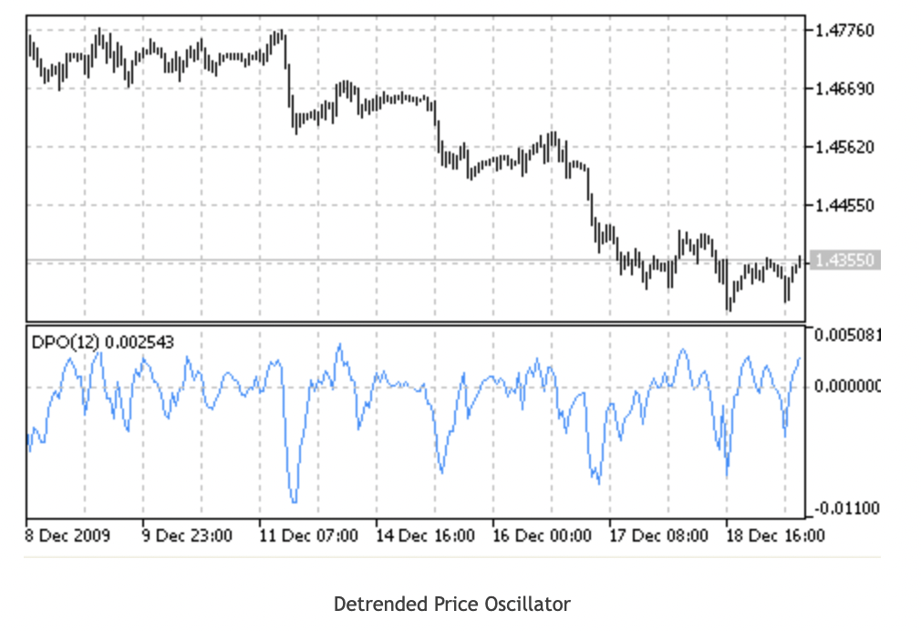

Formula: DPO = CLOSE - SMA (CLOSE, (N / 2 + 1))

Python code:  
def detrended_price_oscillator(data, period=14):

shifted_price = data['Close'].shift(int(period / 2) + 1)

dpo = data['Close'] - shifted_price

dpo = dpo.shift(-(int(period / 2) + 1))

return dpo

crypto_data['DPO'] = detrended_price_oscillator(crypto_data)

**McClellan Oscillator:** This is a market breadth indicator that uses the difference between advancing and declining issues to identify the strength or weakness of a market trend.

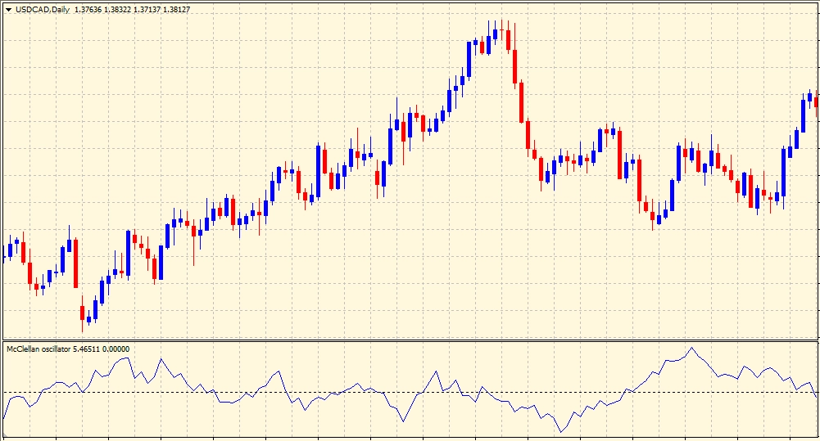

Formula:

McO (t) = EMA (fast, t) (Advances (i) – Declines (i)) – EMA (slow, t) (Advances (i) – Declines (i))

Python code:

def mcclellan_oscillator(data, short_period=19, long_period=39):

adv_dec_diff = data['Advances'] - data['Declines']

short_ema = adv_dec_diff.ewm(span=short_period, adjust=False).mean()

long_ema = adv_dec_diff.ewm(span=long_period, adjust=False).mean()

oscillator = short_ema - long_ema

return oscillator

market_breadth_data['McClellan_Oscillator'] = mcclellan_oscillator(market_breadth_data)

**Chande Momentum Oscillator (CMO):**

CMO measures the momentum behind a price movement. It is designed to be more responsive to price changes than traditional momentum oscillators.

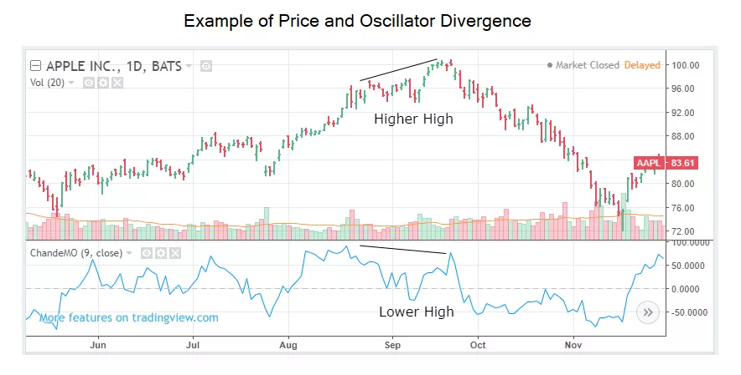

**Formula:**

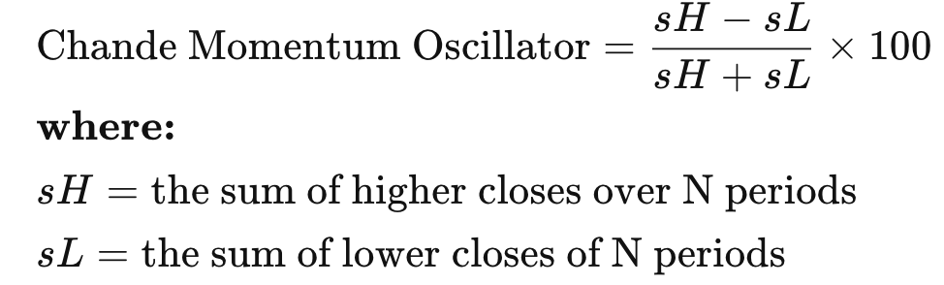

**Python code:**

def chande_momentum_oscillator(data, period=14):

close_diff = data['Close'].diff()

gain = np.where(close_diff > 0, close_diff, 0)

loss = np.where(close_diff < 0, abs(close_diff), 0)

smooth_gain = pd.Series(gain).rolling(window=period, min_periods=1).mean()

smooth_loss = pd.Series(loss).rolling(window=period, min_periods=1).mean()

cmo = 100 * (smooth_gain - smooth_loss) / (smooth_gain + smooth_loss)

return cmo

price_data['CMO'] = chande_momentum_oscillator(price_data)

**On-Balance Volume (OBV):**

OBV measures buying and selling pressure by adding the volume on up days and subtracting it on down days. It's used to confirm price trends and anticipate potential reversals.

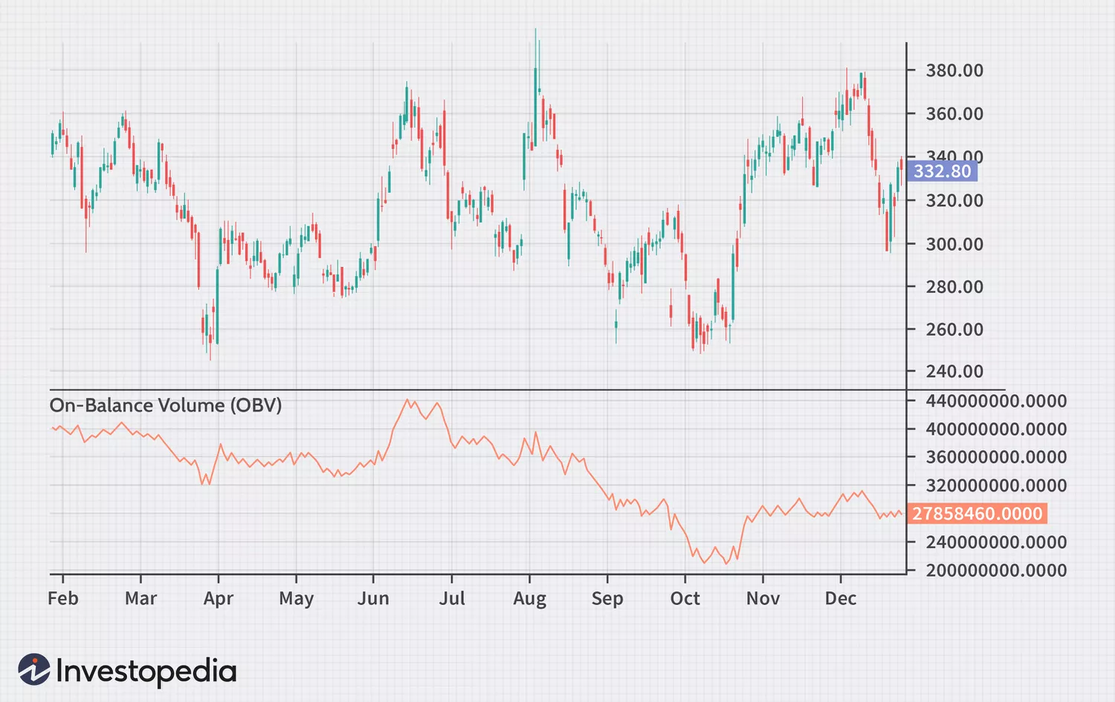

**Formula:**

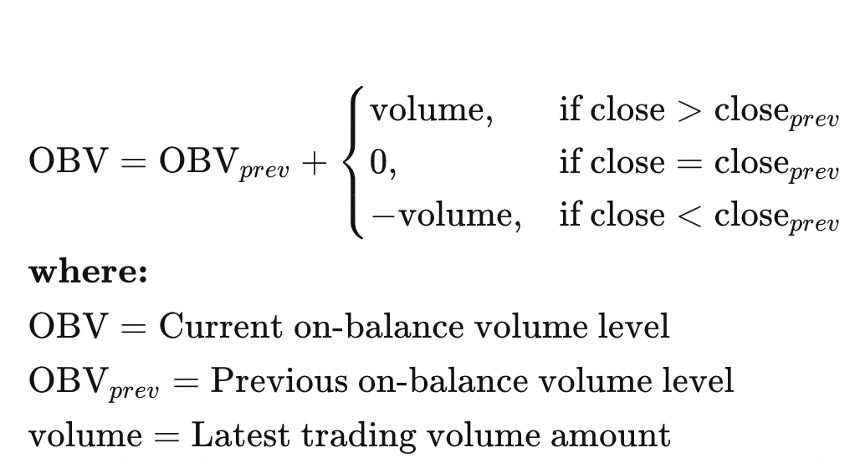

def on_balance_volume(data):

obv = np.zeros_like(data['Close'])

obv[0] = data['Volume'].iloc[0] if data['Close'].iloc[0] > data['Close'].iloc[1] else -data['Volume'].iloc[0]

for i in range(1, len(data)):

if data['Close'].iloc[i] > data['Close'].iloc[i - 1]:

obv[i] = obv[i - 1] + data['Volume'].iloc[i]

elif data['Close'].iloc[i] < data['Close'].iloc[i - 1]:

obv[i] = obv[i - 1] - data['Volume'].iloc[i]

else:

obv[i] = obv[i - 1]

return obv

price_volume_data['OBV'] = on_balance_volume(price_volume_data)

**Strategy 1**

**(O-C)*Vol** - extreme values , mean values , standard deviation , change in price(t+1 - t) when values are close to the mean and at the extremes

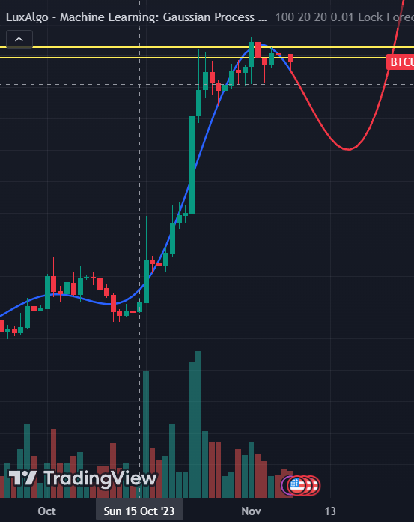

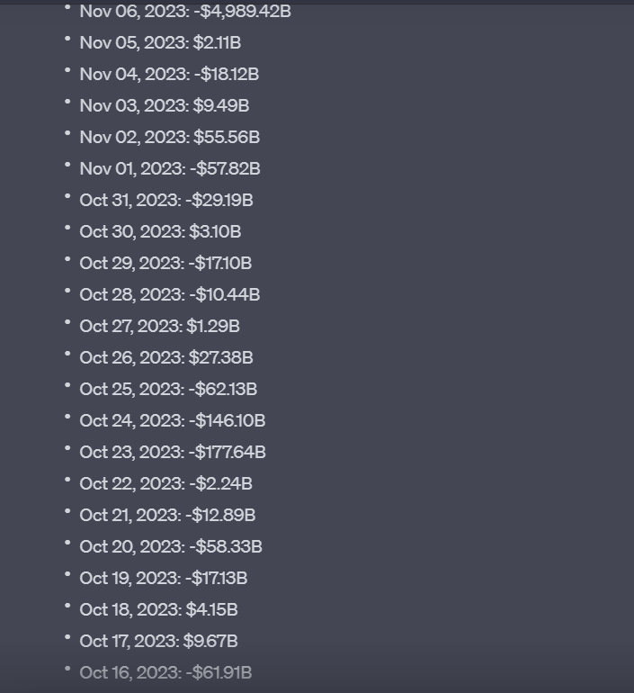

‘def plot_custom_strategy(df, start_date, end_date, start_hour=None, end_hour=None):

start_datetime = pd.to_datetime(start_date)

end_datetime = pd.to_datetime(end_date) + pd.Timedelta(days=1)

if start_hour is not None:

start_datetime += pd.Timedelta(hours=start_hour)

if end_hour is not None:

end_datetime += pd.Timedelta(hours=end_hour) - pd.Timedelta(days=1)

filtered_df = df[(df.index >= start_datetime) & (df.index <= end_datetime)]

filtered_df['strat_1'] = (filtered_df['open'] - filtered_df['close']) * filtered_df['volume']

add_plot = [

mpf.make_addplot(filtered_df['strat_1'], panel=1, color='orange', ylabel='Strat_1'),

mpf.make_addplot(filtered_df['close'], panel=2, color='blue', ylabel='Close')

]

mpf_style = mpf.make_mpf_style(base_mpf_style='charles', rc={'figure.facecolor': 'lightgray'})

mpf.plot(filtered_df,

type='candle',

style=mpf_style,

addplot=add_plot,

figratio=(2,1),

volume=True,

title=f"BTC Trading Data with Custom Strategy from {start_date} {start_hour or ''} to {end_date} {end_hour or ''}",

panel_ratios=(6,3,2))

plot_custom_strategy(df_5min, '2020-01-01', '2020-01-01', start_hour=9, end_hour=10)

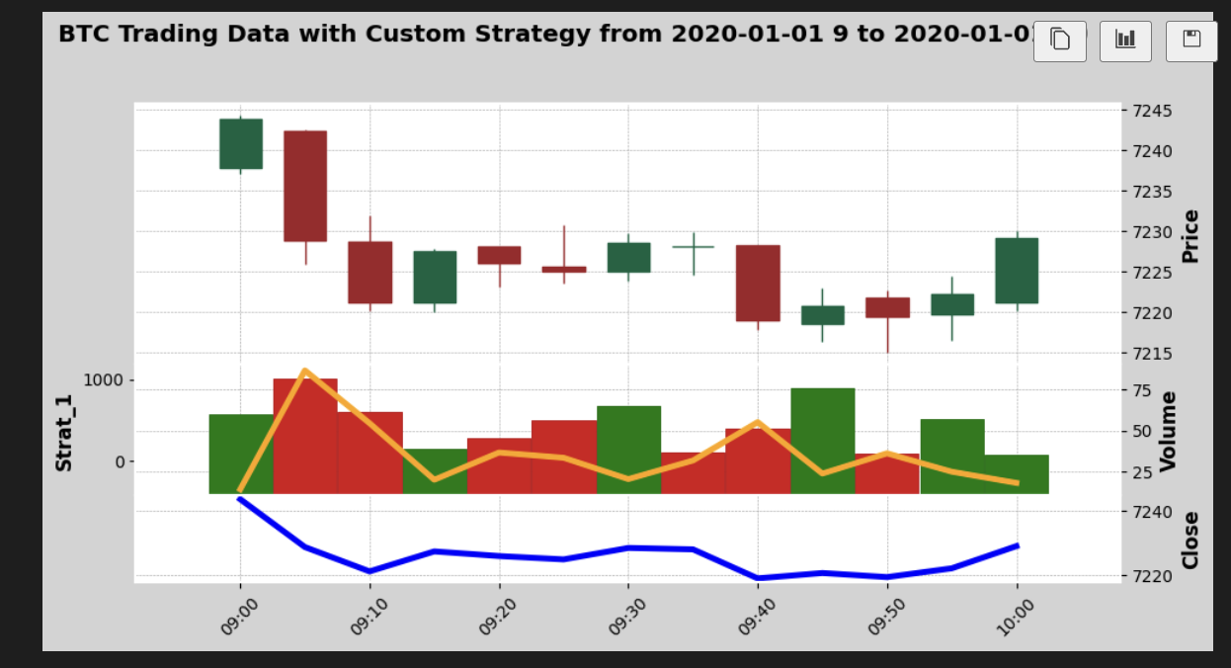

Run a specific strategy, such as MACD, and based on historical data, calculate the probability of the next trade being profitable. I mean, in historical data, which includes separate sets for sideways markets and trending markets, determine the probability of the next trade being profitable after a win, and similarly, if there are consistently two wins or two losses. And define a confidence parameter which tells what the probability is of the next trade being profitable." for determining whether there’s volatility or not consider the moving average of volumes traded over 1 day tick size and defining a threshold below which we’ll consider market to be non volatile ( lets say below half of the max and min values of this for simplicity ) and consider that to be sideways